**P7 – Test a computer system for functionality**

Test plan:

* Check display is properly configured
* Check computer can connect to network
* Check essential programs run correctly (web browser, word processor, etc)
* Check computer works with a projector
* Check the idle CPU usage

Evidence:

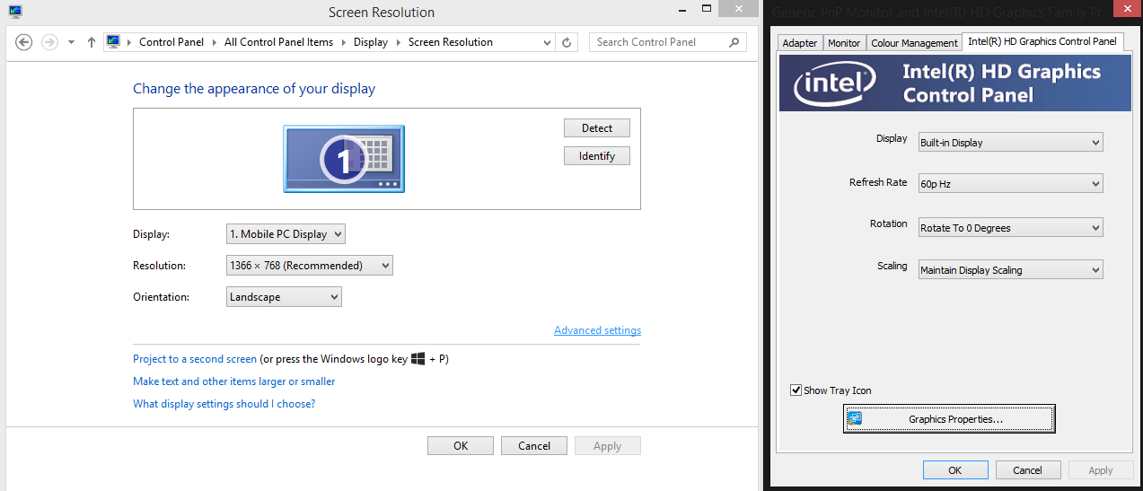

The resolution is set to the recommended resolution. The display fills the monitor but is not larger. Items onscreen are the correct size.

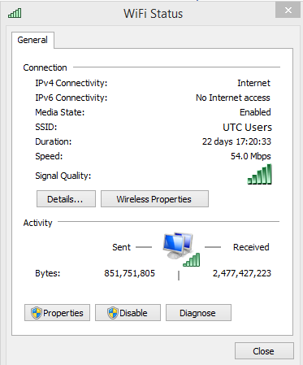

This screenshot shows that the computer has internet access over WiFi.

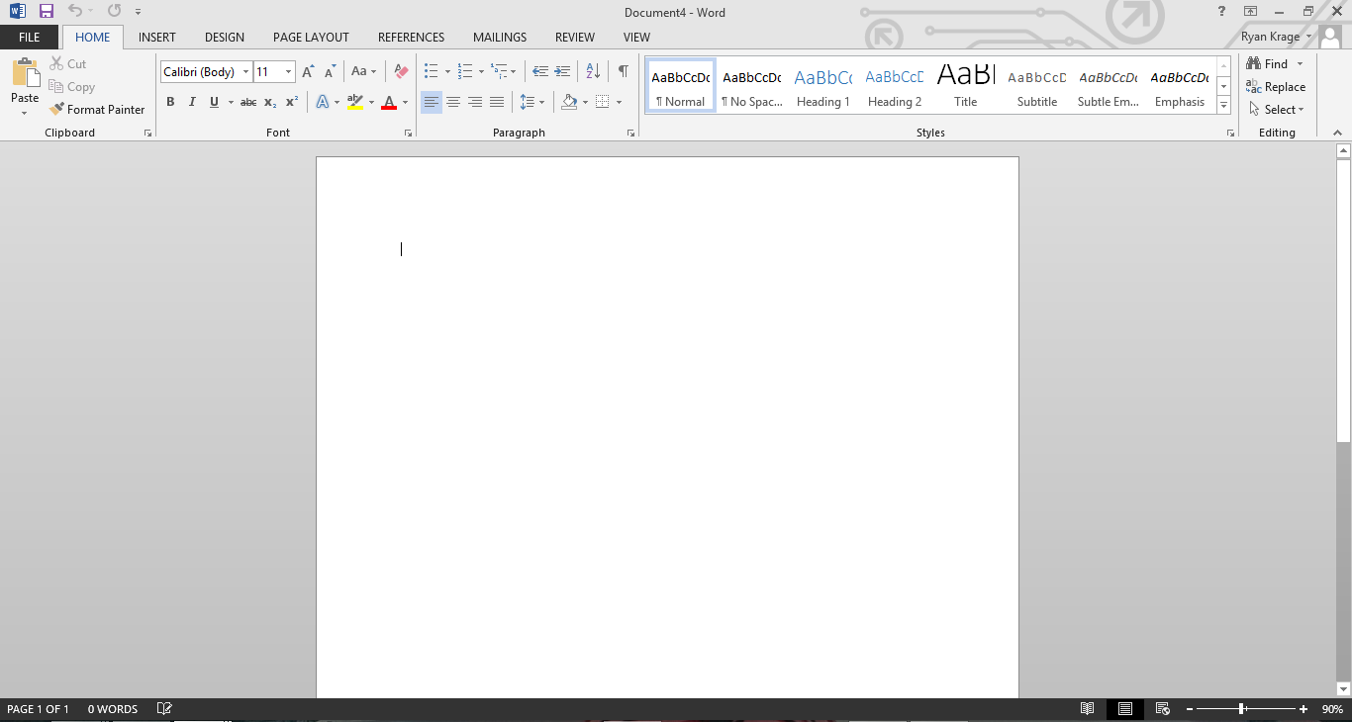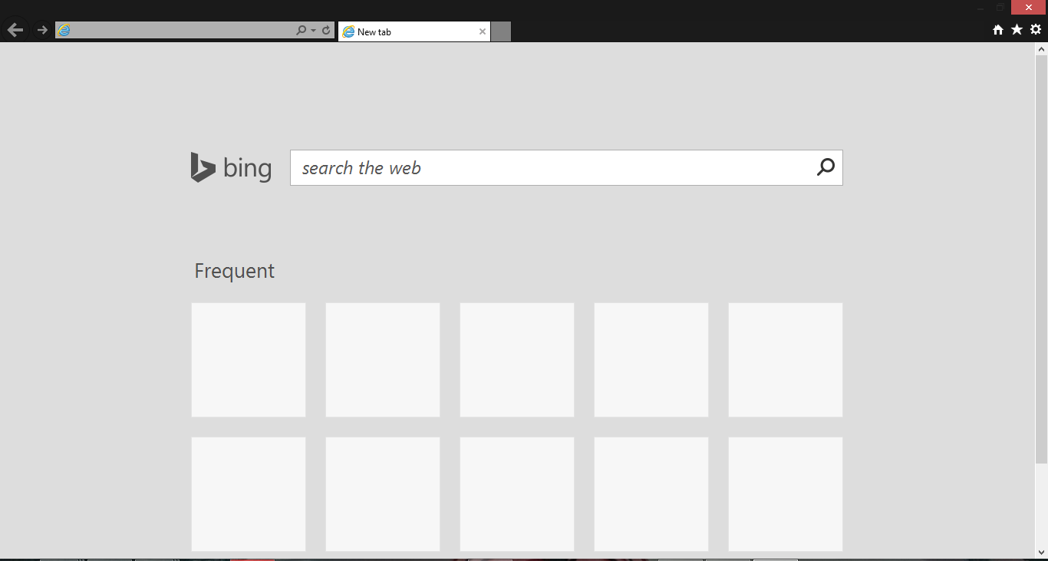

Word and Internet explorer run fine.

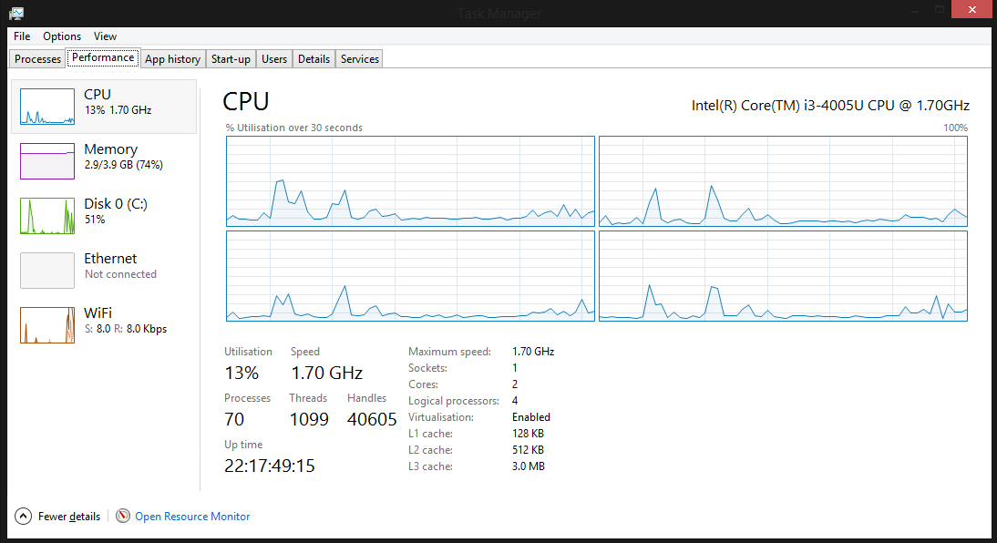

The idle CPU usage is on average under 10%, so there are no programs using excessive amounts if system resources.